
Under menu
List your Property
Agreements
Tenants Plan
Owner Plan

Simple screen
Search
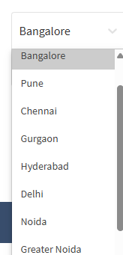

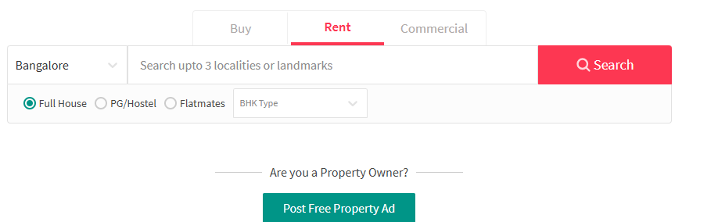

2. Tenant (Renter) Plans
The goal here is to save them money (brokerage) and ensure the house is safe.
Feature | Explorer (Basic) | Verified (Pro) | Assurance (Gold)
Price (Estimated) | ₹0 / Free | ₹499 | ₹1,299
Brokerage Fee | Zero | Zero | Zero
Street View | ✅ | ✅ | ✅
Property Access | 3 Contacts/day | Unlimited Contacts | Early Access (6h before)
Verification | Basic | Verified Badge | Police Verification
Legal Document | View only | e-Sign Included | e-Sign + Digital Stamp
Tax Support | - | Auto HRA Receipts | Auto HRA Receipts

1. Owner (Landlord) Plans
The goal here is to help them find a high-quality tenant quickly with zero effort.
Feature | Starter (Basic) | Speed (Pro) | Managed (Gold)
Price (Estimated) | ₹0 / Free | ₹999 | ₹2,999
Listing Visibility | Standard | Premium Boost (Top) | Featured (First Page)
Inquiries | Limited (5) | Unlimited | Unlimited
Photography | Self-upload | Self-upload | AI-Photo Enhancement
Tenant Screening | Basic ID Check | Aadhaar + PAN Check | Full Background Check
Legal | DIY Draft | E-Sign + E-Stamp | E-Sign + E-Stamp
AI Support | Bot only | Priority WhatsApp AI | Human Concierge

